Information

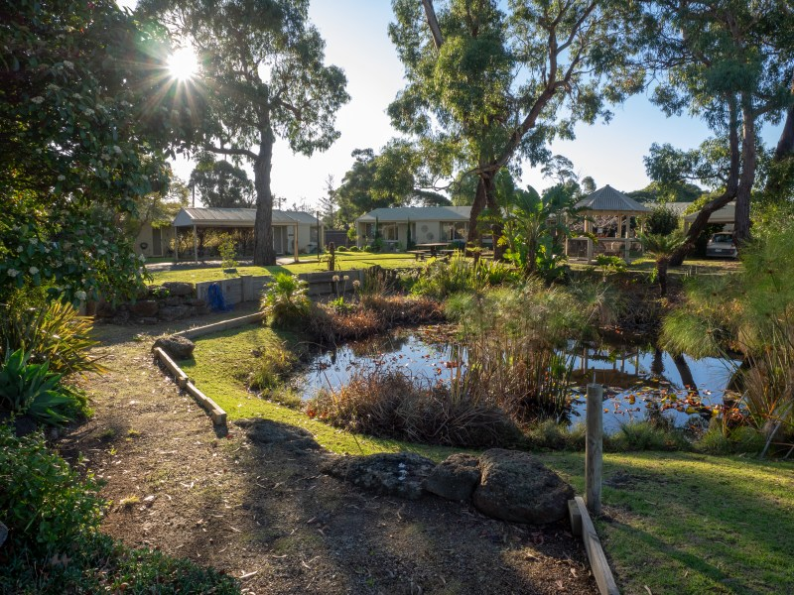
Rosebud Village has a wonderful community spirit. This is a small community providing companionship, support and security for Residents. The Village is conveniently located with a corner shop next door and close to Waterfall Gully shops, Rosebud shopping precinct and lovely beaches. With a bus stop located at the entry to the Village and the Village bus operating three times a week, all local services are easily in reach. The Village has a variety of amenities including hairdresser, billiard room, library and community centre with a diverse activities program.

One bedroom and two bedroom Units are available with a total of 105 Units at the Village. Units have a spacious open plan modern kitchen and lounge, a contemporary walk-in shower and tasteful, harmonious décor throughout. The monthly service levy includes maintenance of common areas including the Community Centre and gardens, nursing staff on duty five days a week as well as a 24 hour emergency call service, water and municipal rates, building insurance and other support staff and services.

Home and Community Care
Our services are used by local hospitals as part of the post-acute care programs, Transport Accident Commission, Department of Veterans Affairs, Local Government and Community Aged Care Package programs. Our staff provide a flexible and friendly service to ensure that the needs of the client are achieved. Our Home Care services are available to persons of all ages, from mothers with new born infants through to older persons seeking support.
Services we offer:
Meals at Home, Domestic Services, Home Nursing, Personal Care Services, Shopping and Transport, Home Maintenance, Grounds and Gardening.
For further information call us on 5971 6308

Rosebud Village Amenities
- Library
- Billiard Room
- Lounge with Coonara fireplace
- Undercover Outdoor BBQ Area
- Hairdresser
- Workshop
- Vegetable Garden
- Enrolled Nurse available during office hours
